1. Draw the shear flow diagram for the transverse cross section shown below. Given that the vertical shear = 10 kN in the section, NA is at 5.48 m from bottom, MoI about NA = 19 $m^{4}$.

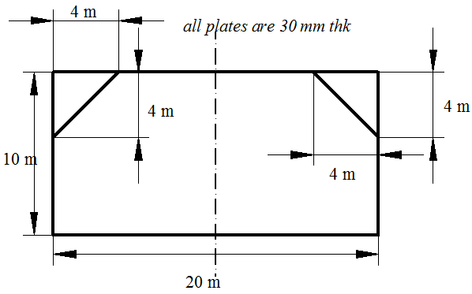

1. Calculate the values of $J_{t} and J_{ω}$ for the section shown below.

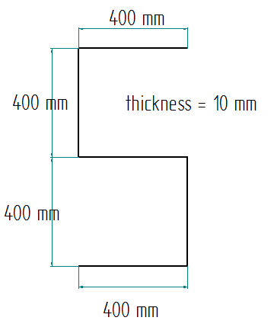

1. Show that the shear flow along the peripheral edge of a thin walled closed section is constant.